**1.Title: Online GYM Management System**





**2. Project Statement:**

The project aims to develop a user-friendly web application that facilitates the

Gym Management Software is a gym and health club membership management system. You can keep records on your members, their memberships, and have quick and easy communication between you and your members. Gym Management also includes a booking system, point of sale, banking, accounting, concessions and has a range of reports that help in the management of your club.

**Outcomes:**

Our Gym Management Software is a complete gym and recreation facility system program which looks after all of your members, memberships and activities. It is designed for gyms, recreation center, and health clubs.

Enhance customer satisfaction by offering a seamless and user-friendly interface.

1. **Modules to be implemented**
2. User Authentication and Registration
3. Gym Slot Scheduling Interface
4. Slot availability Management
5. Slot Booking Information Management
6. FeedBack Management
7. Notification System
8. Admin Dashboard
9. **Week-wise module implementation and high-level requirements with output screenshots**

**Milestone 1: Weeks 1-3**

**Module 1: User Authentication and Registration**

* Implement user registration functionality.
* Develop user login mechanism.
* Integrate email verification and password reset features.
* Output screenshot:



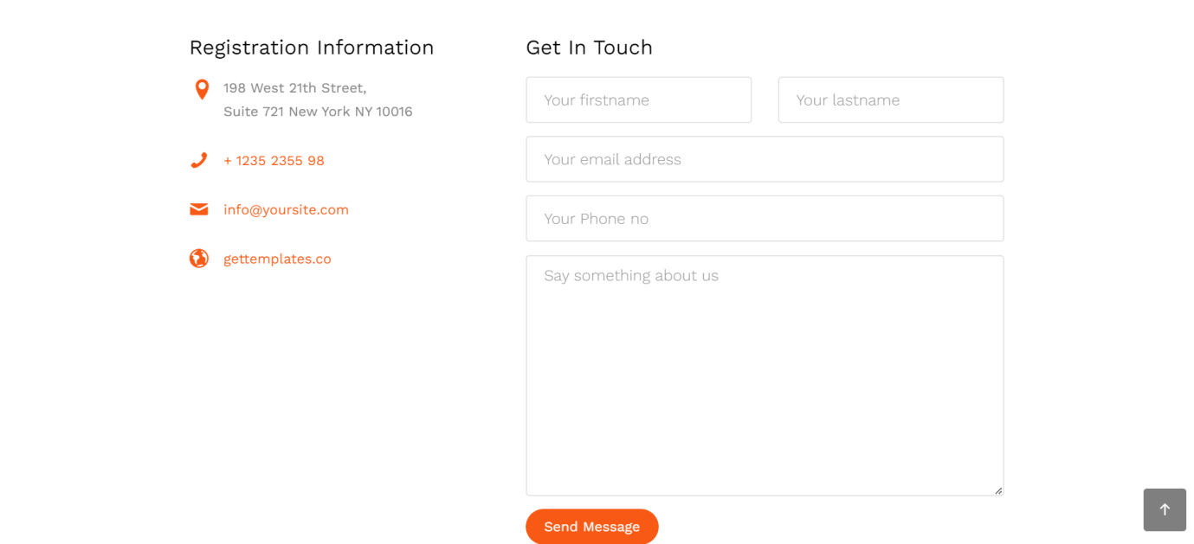

**Module 2: Gym Slot Scheduling Interface**

* Design database schema for storing gym slot availability information.
* Develop an interface for gym slot to set their availability.
* Implement backend functionality to manage and update slot availability.
* Output screenshot





**Milestone 2: Weeks 4-5**

**Module 3: Slot availability Management**

* Design and develop the interface for slot scheduling.
* Implement functionality for users to select slot, preferred time slots.
* Integrate the scheduling interface with the backend for storing time slot details.
* Output screenshot

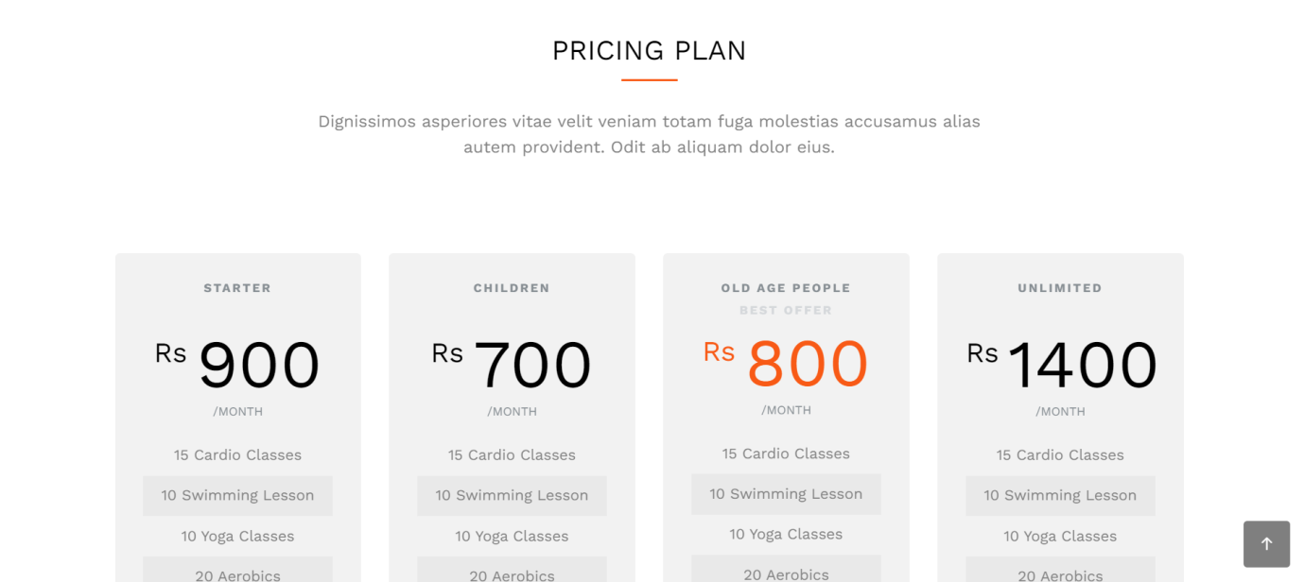

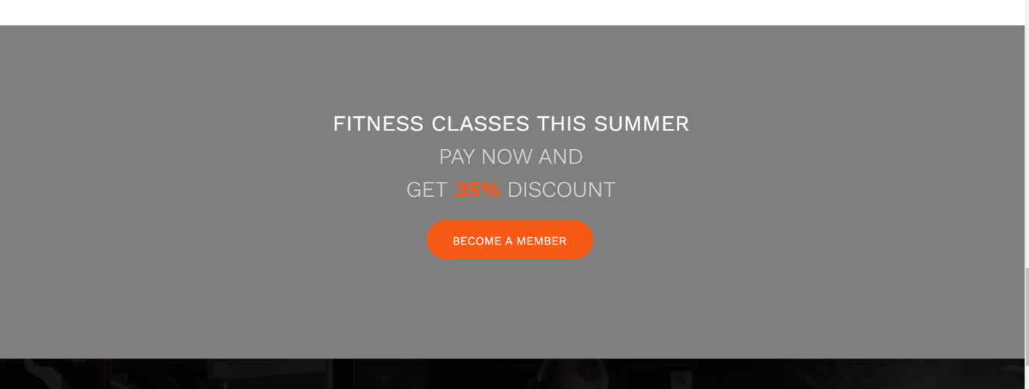

**Milestone 3: Weeks 6-7**

**Module 4: Slot Booking Information Management**

* Design database schema for storing slot details.
* Implement backend functionality for scheduling slotand preventing conflicts.
* Develop an interface for Organizer and Customer to view and manage slot.
* Output Screenshot:

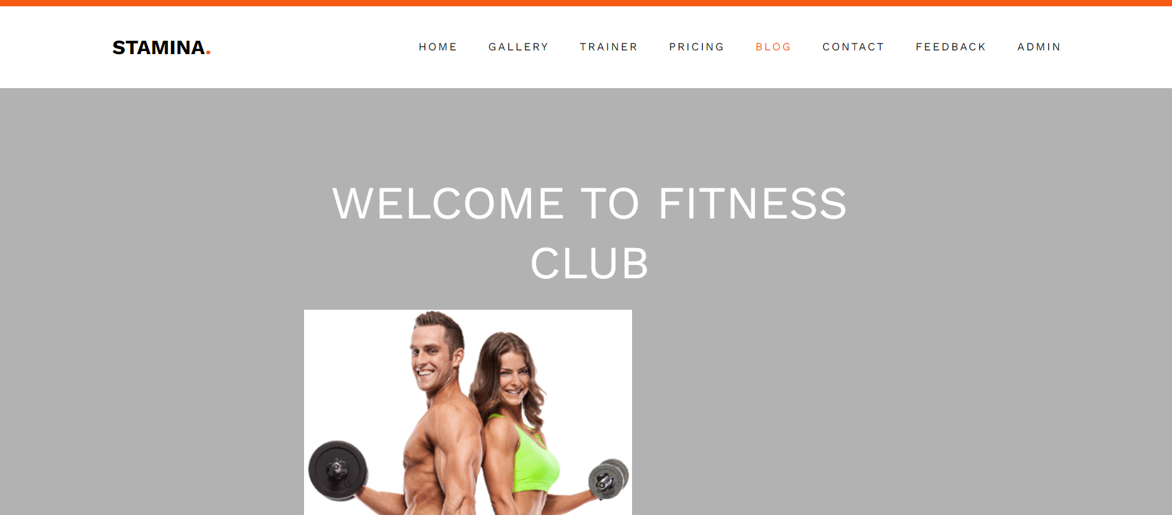

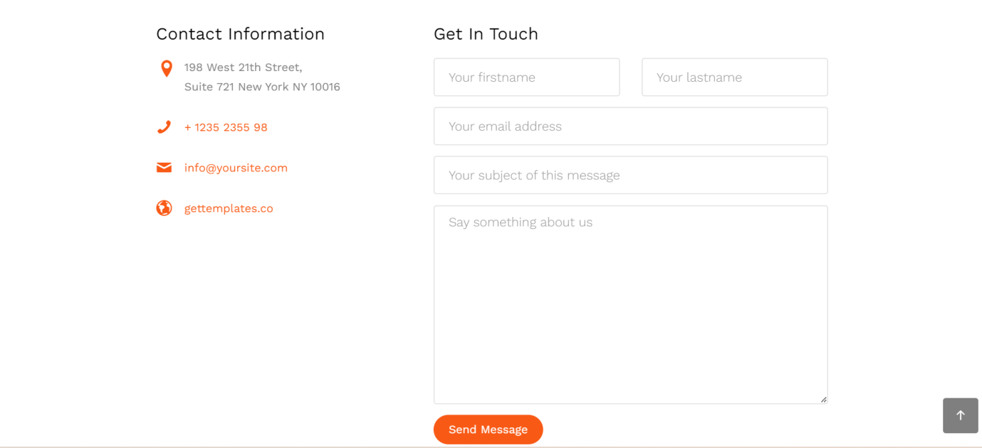

**Milestone 4: Weeks 8-10**

**Module 5: Customer Feedback Information Management**

* Design database schema for storing customer information securely.
* Develop functionality for customer to provide and update their information.
* Implement backend logic for accessing and managing customer information securely.
* Output Screenshot:

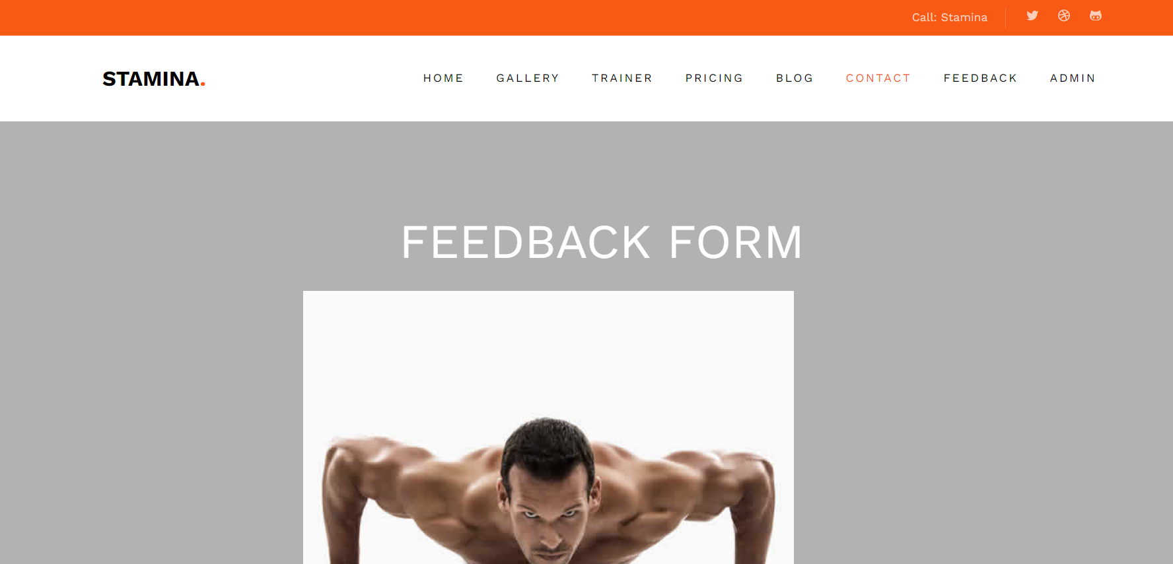

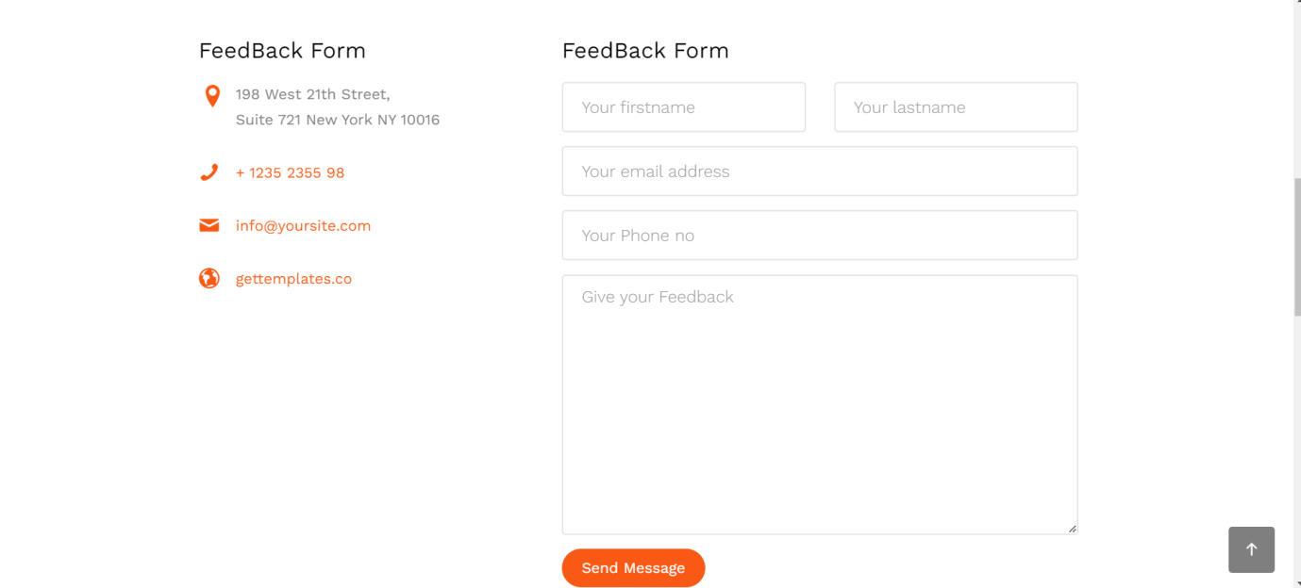

**Module 6: Notification System**

* Integrate email and/or SMS notification services.
* Develop triggers and notifications for appointment reminders, new bookings, and cancellations.
* Implement a system for handling and tracking notifications.
* Output screenshot:

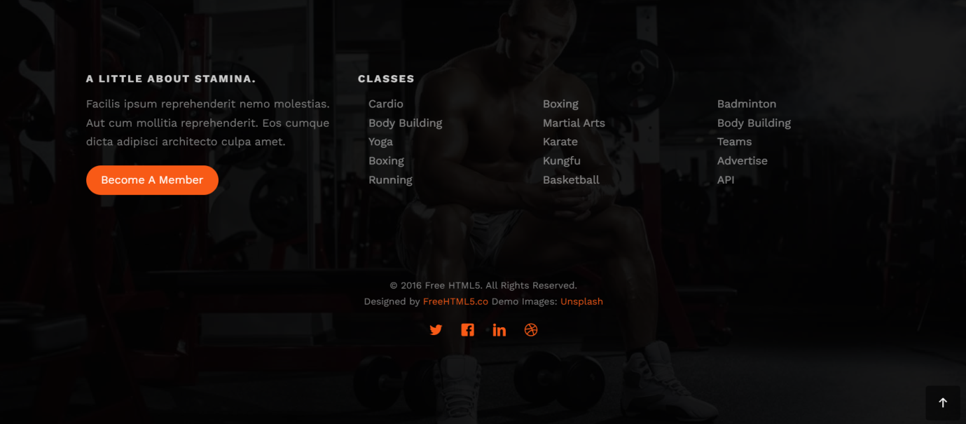

**Module 7: Admin Dashboard**

* Design the layout and functionality of the admin dashboard.
* Implement user management features for admin to add, edit, and delete users.
* Develop modules for managing doctors, slot, and customer information.
* Output Screenshot:



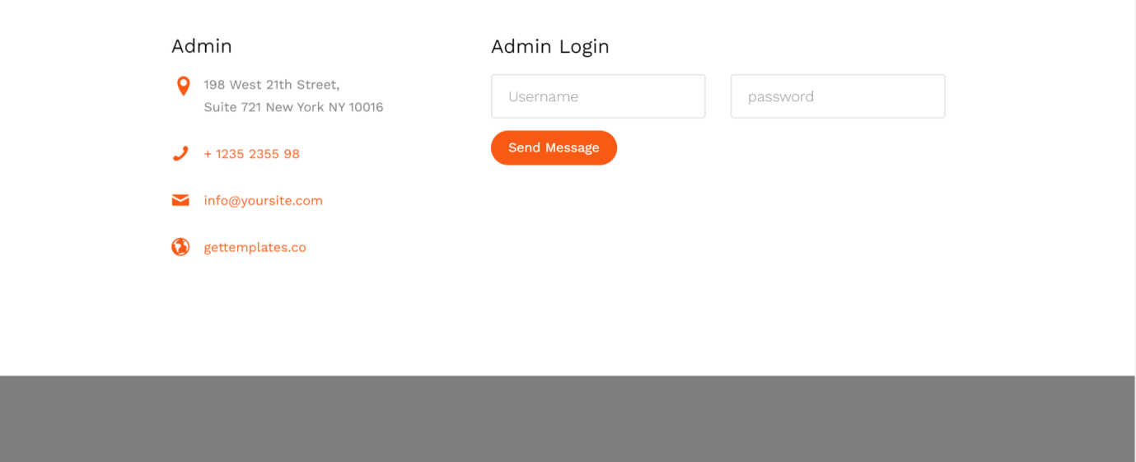

**Evaluation Criteria:**

**Milestone 1 Evaluation (Week 3):**

* Completion of user authentication and registration.
* Successful implementation of trainer availability management functionalities.

**Milestone 2 Evaluation (Week 5):**

* Appointment scheduling interface is fully developed and integrated with the backend.

**Milestone 3 Evaluation (Week 7):**

* Appointment management system is operational, allowing for scheduling and viewing slot.

**Milestone 4 Evaluation (Week 10):**

* Customer information management, notification system, and admin dashboard are fully implemented and functional.

1. Design diagrams

Class Diagram: Entity classes

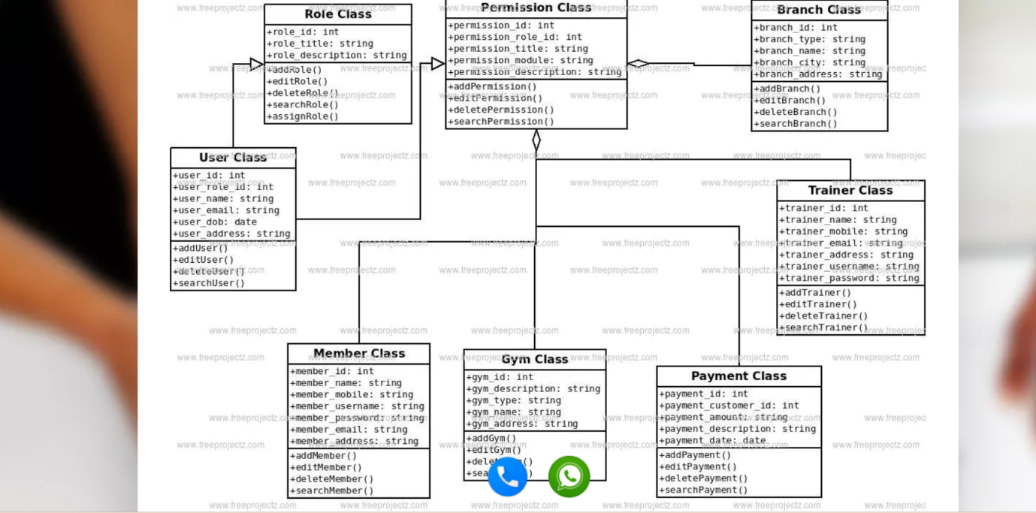

**Output Screenshots:**

1. Dashboard



2. Admin Dashboard

